# London’s Rising Housing Prices

London has seen the greatest average increase in housing prices over the two decades

There are 32 London boroughs within Greater London, and each borough has its own governing council. Some of them are more desirable to live in and will reflect that desirability in a greater rise in housing prices.

We found Hackney is the most expensive, showing price rise by 6.16 ratio for 2018.

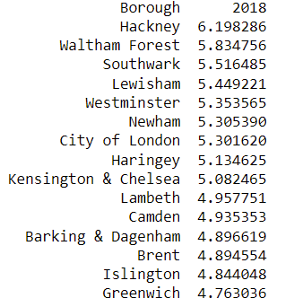

Average price rise for Hackney over past 2 decdes 